Practical 5: Doubly Linked List and Circular Linked List
Problem 1
A music player maintains a playlist where songs can be added to the beginning, added to the end, or inserted after a specific song that is currently playing. When a song is removed, only the first song in the playlist is dropped. At any point the player can count how many songs are in the playlist and display them from first to last. Given a sequence of such operations, implement all of them on a doubly linked list and print the result after each operation.
Describe how your insertion after a given song works. What extra step does a doubly linked list require here that a singly linked list did not? What happens if the given song is not found in the playlist?
Code
https://github.com/AD-9218/DATA-STRUCUTURE-AND-ALGORITHM/blob/main/practical-5/5_1.cpp
Output
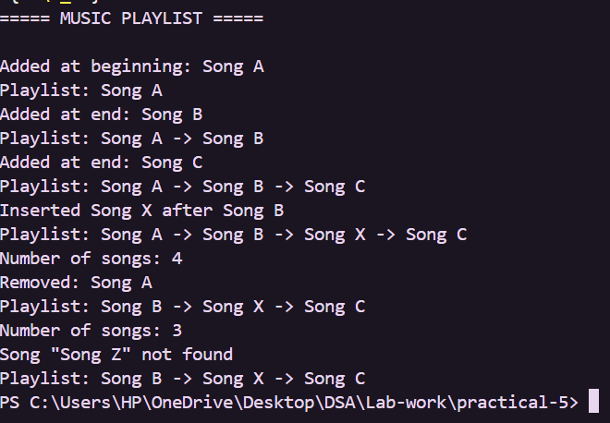

Problem 2
A group of students are sitting in a circle playing a passing game. A token starts at the first student and is passed around the circle one student at a time. Students can join the circle at any time, and the circle must remain unbroken after every join or leave. If a student leaves, the next student becomes the new first student. Implement the circle using a singly circular linked list and print the current circle after each operation.
Describe how your solution ensures the circle stays unbroken after a student leaves. What is the one case where breaking the circle is most likely to happen as a bug, and how did you handle it?
Code
https://github.com/AD-9218/DATA-STRUCUTURE-AND-ALGORITHM/blob/main/practical-5/5_2.cpp

Output
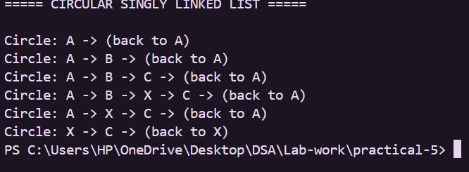
Key Questions / Analysis / Interpretation
1. Problem 1: A doubly linked list maintains two links per node instead of one. Explain why having a backward link on the second node creates a responsibility that did not exist in a singly linked list and what goes wrong if you forget to handle it.
Answer: When inserting a node, both the next and previous links must be updated. If the previous link of the next node is not updated, backward traversal will point to the wrong node.
2. Problem 2: If traversal of the circular list does not stop at the right moment, it will loop forever. Without referencing any specific code, explain what condition must be true at the moment you stop, and why that condition would fail if you set the last node's link to null.
Answer: Traversal should stop when the current node becomes the starting node again. In a circular list the last node points back to the first node; setting it to null breaks the circle and changes the traversal behavior.

